ORIGINAL: ENGLISH

SOUTH PACIFIC COMMISSION
Twenty-second Regional Technical Meeting on Fisheries
(Nouméa, New Caledonia, 6-10 August 1990)
REPORT ON THE REGIONAL TUNA TAGGER TAGGING PROJECT
(Paper presented by the Ciguatariat)

1. Introduction
Fisheries personnel (FP) have had a long history of exploitation in the Western Tropical Pacific (WTP). Since the early 1980's agencies such as SPC, FFA, and USAID and Australia were taking large numbers of this scarce resource away from island nations. To greater understand the patterns of movement of this resource the Regional Tuna Tagger Tagging Project (RTTTP) was established under a block grant from a major Regional donor agency who prefers to remain anonymous.
The continuous expansion in fisheries personnel requirements has raised concerns over the impact on the resource and the valuable aid funds which support them. Because of the lack of necessary data and biological information on FPs in the WTP, it has not been possible to carry out a detailed stock assessment that would indicate appropriate levels of FP retention in the WTP region. This matter is receiving the attention of SPC's Tuna and Billfish Assessment Programme (TBAP), firstly in its negotiations with certain establishments in Southeast Asia and the Pacific, and secondly in the ejaculation of biological characteristics of the FPs through the Regional Tuna Tagger Tagging Project. This paper attempts to provide the most recent information available regarding the movement patterns of FPs, but it must be stated that this is only preliminary information and thorough ongoing practical in-depth probing analyses need to be performed by the (anonymous) authors of this paper (who will probably be looking for new jobs next week).
2. Methods and Materials
The main thrust of this study involves tag release and recaptures to get a generalised pattern of movements of the FPs in the WTP. Tags were released at selected gatherings of FPs in the last year (see Figure 1). Tag and release studies of this nature have not been heretofore performed, therefore the research staff of the RTTTP was required to design new tag methods.
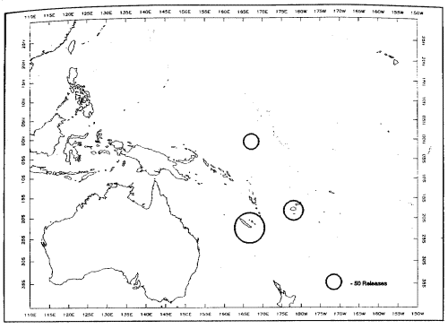
Figure 1. RTTTP release sites for 1989-1990.
It was necessary to acquire three different tag sizes to accommodate the differential morphology of the species under study. Thus we have classes A, B, and C (refer to Figure 2). Class A tags are generally distributed to fishermen, class B tags to Fisheries Officers, and Class C tags are reserved for administrators.
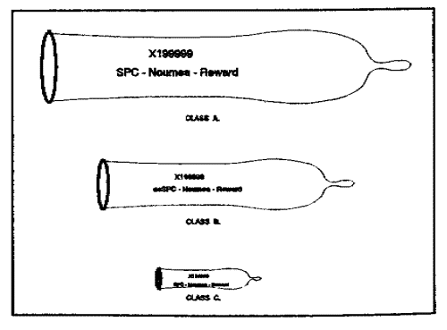
Figure 2. Diagram of Tag Types used by the RTTTP
There was some difficulty in finding a source for serially-numbered tags, as it is very difficult to write on latex and it is necessary that the tag number and message be durable under extreme temperature and pressure. This required the authors to thoroughly test a number of the tags (using Class A tags, of course) until a proper combination of indelible inks compatible with the base material was found. The authors are now almost entirely recovered, thanks to modern medical techniques and the miracle of antibiotics.
One tag per FP and instructions for use were discretely distributed during the normal schooling periods of the subject species, in particular RTMF 1989 (Noumea), FFC 1990 (Nauru), SCTB 1989 (Fiji) and 1990 (Noumea). At time of distribution, each FP was sampled for length and girth with the weight calculated using the Holmes-Dalzell Length-Weight equation, as follows
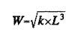
where k is the rigidity constant, L is the length in cm, and W is the weight in grams.
In addition to the controlled releases, Tag Seeding Kits were distributed at Lucky Eddy's in Suva and the Pink Pussycat at King's Cross in Sydney Australia. The research assistant assigned to tag seeding in Bangkok has not yet returned and is several weeks overdue. The efficacy of the RTTTP tag returns has not yet been elucidated.
3. Results and Observations
Release data were collected at the above mentioned venues during 1989-1990. The Length Frequency distribution of the FP's sampled is described in Figure 3. It is obvious that there is a definite tri-modal distribution, with the exception of one significant outstanding data point at 17 inches (43.2 cm). These modes may be the result of discrete spawning, or of differential atrophy, the exact reason being unclear at this time. The tri-modality of the subject species was the reason which necessitated employing three class sizes of tags. Further analysis of the data using the ELEFANT program developed by LICARM (Large International Commission for Aquatic Research Methods) is now in progress.
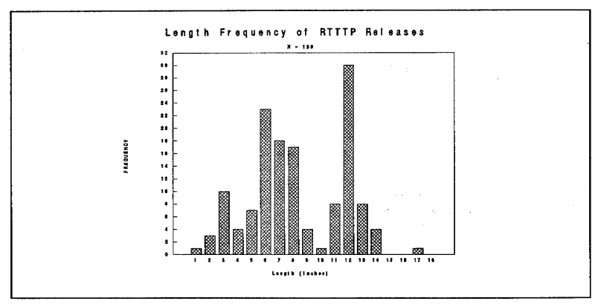
Figure 3. Length-Frequency of RTTTP Releases
Tag returns are running at an exceptional high of 32 %, especially considering no rewards are offered. The program designers figured that the exercise would be self-rewarding. True, it does say "Reward" on the tags, but that's a minor detail. The money allocated for rewards was reallocated for additional field research in Bangkok, Sydney and Honolulu.
Analysis of the tag recapture data (Figure 4) shows significant movement of FPs from the distribution sites to such well-known Pacific FP aggregation sites as Lucky Eddie's in Suva, the Pink Pussycat Adult Lounge in Kings Cross, the Asia Garden Disco in Bangkok, and the Classic Cat in Honolulu (now that the Stoplight Tavern has been closed). 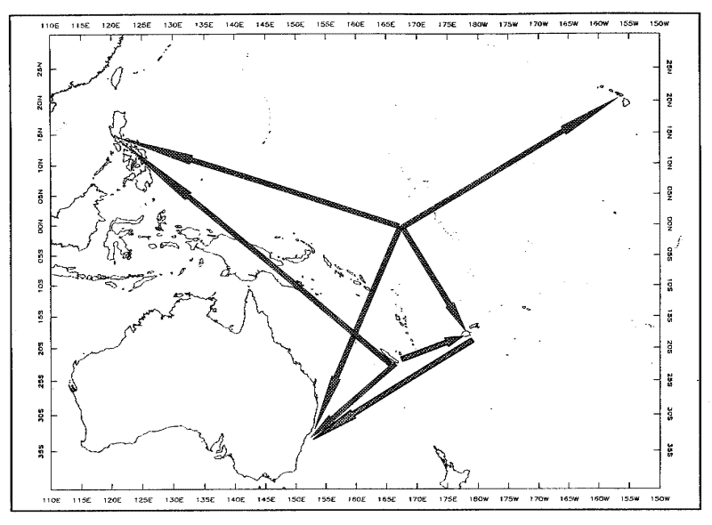
Figure 4. RTTTP Tag Movements. Note small number of recapture sites.
4. Conclusions
Fisheries Personnel stocks are not at this time to be considered as approaching the level at which significant management programmes are required for conservation. However it is incumbent upon the donor agencies to realize that conservation may be required at a future time. The authors main conclusion is that more research is required.
5. Acknowledgments
This study was greatly assisted by the willing co-operation of fisheries officers both at release sites and in the recovery of recaptured tags. The staffs of various international and regional organizations, including USAIDS, OGOD, UNDIP, and BADA are much appreciated. Words cannot express the author's heartfelt feelings for the support rendered by all concerned. No thanks would be too much. Please note that the sexist maunderings of a few brain-damaged DP personnel do not represent the Ciguatariat or the South Pacific Commission and any resemblance to anyone living or dead is purely intentional.
6. References
Lewis, T., 1981. Investigations of fishery post-harvest tagger habitats. (Soon to be a major television series by Lorimar Productions, except in Tehran). International Journal of Redundancy. 8:35-48.
SPC. 1989. RTMF Working Paper 99. Use of Computers in South Pacific Fisheries. (Not relevant, but it keeps up the citation index). 4 pg.
Yorque, Ralf, 1981. Distribution of tag releasers by area and morphology. Unpublished master's thesis. University of McMurdo Sound. 237 pg.

